**Comparison and Simulation of Process Scheduling Algorithms: Round Robin, SJF, and Priority Scheduling**

Zhuoying Cai(2104069)

Na Fang(2089103)

Qingyun Zhang(2095754)

**Contents**

ABSTRACT 1

I. INTRODUCTION 2

II. PROJECT OVERVIEW 2

III. REQUIREMENT DEFINITION 3

IV. IMPLEMENTATION 6

V. TESTING RESULTS AND FINDINGS 11

VI. CHALLENGES 34

VII. FUTURE STUDY 38

VIII. CONCLUSION 39

REFERENCE 42

**ABSTRACT**

Through simulation and comparison under varying workloads, this project explores the performance of three classic process scheduling algorithms—Round Robin (RR), Shortest Job First (SJF), and Priority Scheduling.

We will design a simple process scheduling simulation system to evaluate each algorithm across multiple scenarios, including CPU-intensive, I/O-intensive, and mixed-process queues. We will comprehensively assess each algorithm's strengths and weaknesses regarding scheduling fairness, efficiency, and resource utilization by analyzing key scheduling metrics such as average waiting time, response time, and context switch frequency.

Additionally, we will identify optimal use cases for each approach. The final results, presented through detailed experimental data comparisons, will enhance understanding of the applicability and performance differences among these scheduling strategies in real-world applications, ultimately guiding practitioners in selecting the most suitable algorithm based on specific system requirements.

1. **INTRODUCTION**

Effective scheduling is critical for optimizing process performance in a computing environment. It plays a crucial role in ensuring efficient use of system resources, reducing waiting times, maximizing throughput, and balancing the load across different tasks. A well-designed scheduling strategy can mean the difference between smooth system performance and frustrating bottlenecks in multi-user or multitasking systems, where numerous processes compete for limited resources.

This project introduces a scheduling simulation tool to enhance understanding of critical process scheduling algorithms such as Round Robin, Shortest Job First (SJF), and Priority Scheduling. These algorithms, each with its distinct approach to process management, serve as foundational concepts in operating system design. However, grasping their impact and behavior in real-world scenarios can only be challenging with visual and interactive support.

The project seeks to make operating system concepts tangible for students and learners by providing a hands-on way to visualize complex scheduling concepts. The design prioritizes interactivity, allowing users to experiment with different process configurations, observe how the scheduling algorithm affects process execution, and understand the trade-offs between various scheduling techniques. The ultimate goal is to bridge the gap between theoretical knowledge and practical understanding of process scheduling in computer science.

**II. PROJECT OVERVIEW**

This project presents a Python-based scheduling simulation tool that supports multiple scheduling algorithms, including Round Robin, Shortest Job First (SJF), and Priority Scheduling. The tool's primary goal is to better understand how different scheduling techniques work and how they impact process execution within a computing environment. Users can input various processes, each characterized by attributes like arrival time, burst time, and priority, enabling a customized simulation experience that mirrors real-world scenarios.

The tool incorporates a graphical user interface (GUI) built using Tkinter, making it accessible and easy to use even for individuals without extensive programming knowledge. With the GUI, users can enter multiple processes, configure algorithm-specific parameters (such as time slices for Round Robin), and initiate the scheduling simulation with just a few clicks. The interface also visually displays the scheduling timeline, illustrating the process execution order in an easy-to-understand Gantt-like chart. This visualization helps users understand how each algorithm manages CPU resources and handles process scheduling.

To further enhance the tool's utility, it includes functionality for exporting the scheduling results to an Excel file. Using pandas for efficient data management, the results are organized and saved in a format suitable for detailed analysis, which is particularly beneficial for educational purposes or further research. Users can analyze metrics such as waiting times, turnaround times, and CPU utilization, gaining deeper insights into the performance of each scheduling algorithm. The ability to export data also allows users to share results or incorporate them into reports and presentations.

**III. REQUIREMENT DEFINITION**

The requirement definition for this scheduling simulation project involves creating a comprehensive and user-friendly tool for understanding various process scheduling algorithms. The essential requirements include supporting multiple scheduling algorithms, namely Round Robin (RR), Shortest Job First (SJF), and Priority Scheduling, each of which must be selectable by users for comparison and study. The tool needs to allow users to input process attributes, such as arrival time, burst time, and priority, and simulate the behavior of these processes under different algorithms. Metrics like average waiting time, response time, turnaround time, and context switch count must be accurately computed and displayed. Furthermore, the tool should have a graphical representation of the scheduling timeline to enhance user comprehension, with charts and visual indicators highlighting the progression of processes.

The application must be implemented in Python, with Tkinter as the GUI toolkit to facilitate user interaction. The visualization components will be developed using tools like Matplotlib to ensure a clear and informative representation of the scheduling processes. Additionally, the data export functionality is essential; users must be able to save their simulation results to an Excel file for further analysis, utilizing Pandas to handle data processing and exporting. Scalability is critical; the tool must efficiently handle more processes without compromising performance. Lastly, thorough testing and documentation are required to guarantee that the simulation operates correctly, delivering consistent results and providing a reliable educational resource for users interested in operating system concepts and process scheduling.

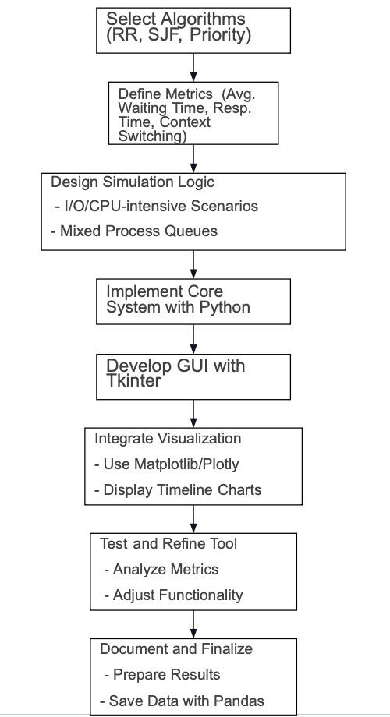

Fig 1: Requirements Definition Flowchart

**IV. IMPLEMENTATION**

1. **Scheduling Algorithm Logic**The simulator implements the following three process scheduling algorithms:

* Round Robin: Allocates a fixed time slice to each process in a circular order.
* Shortest Job First (SJF): Prioritizes processes with the shortest service time. In this project, we decided to implement the preemptive algorithm.
* Priority Scheduling: This algorithm allocates CPU time based on process priority, with higher-priority processes served first. We decided to implement the non-preemptive algorithm.

The scheduling logic for each algorithm calculates essential metrics, including waiting time, response time, and turnaround time, which are displayed in the GUI.

1. **GUI Development with Tkinter**The user interface, designed with Tkinter, enables users to:

* Input Process Data: Users can add multiple processes, specifying each process's arrival time, service time, and priority.
* Select Scheduling Algorithm: Users can choose the desired scheduling algorithm (Round Robin, SJF, or Priority Scheduling).
* Execute Scheduling: A "Start Scheduling" button executes the selected scheduling algorithm and displays results.
* Visualize Scheduling: Dynamic progress bars show the scheduling process, with each process's execution time, start and end times, and other relevant details.

The "Add Process" and "Remove Process" buttons allow dynamic adjustment of the number of processes, and the time slice input box is conditionally used only for Round Robin scheduling.

1. **Visualization of Scheduling Process**
2. **Timeline and Process Blocks** The Canvas widget in Tkinter was extended to display a visual timeline of the scheduling sequence. Key features include:

* Timeline Scale: A horizontal line represents time progression with labeled time points.
* Process Blocks: Each process is a colored block on the timeline. Its start and end times are marked, visually indicating its active period.
* Annotations: Each block includes process details, such as the process number, start time, and end time, to provide clear visual cues about scheduling order and timing.
* Color Management: Different colors are assigned to each process for distinction.

1. **Conditional Judgment for Time Slice** For round-robin scheduling, the tool validates the time slice input. The user is prompted to enter a valid value if the time slice is missing or invalid. The time slice input is ignored for other algorithms (SJF and Priority Scheduling).
2. **Dynamic Process Management**
3. **Adding Processes** The "Add Process" button allows users to add new processes during simulation. Each time the button is clicked, a new row for process data entry (arrival time, service time, and priority) is dynamically created and stored in a list for scheduling calculations.
4. **Removing Processes** A "Remove Process" button lets users delete processes by removing the last-added process or selecting a specific method from a drop-down menu. After deletion, the interface updates to reflect the current list of processes.
5. **Evaluation Metrics and Analysis**
6. **Analysis Goals** The tool includes several evaluation metrics to provide insights into each scheduling algorithm's performance:

* Scheduling Fairness: Measures the balance of waiting and response times among processes.
* Efficiency: Evaluates CPU usage time, aiming to reduce context switches to minimize CPU overhead.
* Resource Utilization: Assesses CPU utilization as a ratio of active CPU time to total scheduling time.

1. **Key Performance Indicators** The following indicators are calculated after each scheduling simulation and displayed in the GUI:

* Average Waiting Time: Average time each process spends waiting for CPU allocation.
* Standard Deviation of Waiting Time: Indicates fairness, with a small standard deviation suggesting balanced waiting times.
* Efficiency: Measured by the number of context switches:

context_switch_count = 0  
# Increment for each process switch  
context_switch_count += 1

* CPU Utilization: Ratio of total CPU execution time to total scheduling time:

def calculate_cpu_utilization(total_execution_time, total_time):  
cpu_utilization = (total_execution_time / total_time) * 100  
return cpu_utilization

* Average Response Time: The average of the first response time across all processes.
* Average Turnaround Time: Average time from process arrival to completion.
* Throughput: Number of processes completed per unit time.

1. **Interface Output Limitations and Export to Excel Functionality**

To address the limitations in interface space for displaying scheduling metrics, the project includes an option to export the scheduling results to an Excel (.xlsx) file. This allows for comprehensively presenting the calculated metrics without crowding the interface.

1. **Implementation of .xlsx Export in Tkinter**

Given the limited display area in the Tkinter GUI, exporting the scheduling results in Excel provides an efficient alternative for storing and reviewing data. The following steps outline the implementation process:

1. **Library Integration**: To support Excel export, the pandas library is used for its robust data handling and xlsxwriter integration capabilities. To implement this, ensure pandas is installed along with the openpyxl and xlsxwriter libraries for Excel file manipulation:  
   bash  
   pip install pandas openpyxl xlsxwriter
2. **Defining the Export Function**: The export function, export_to_excel, is designed to save the scheduling results, including calculated metrics such as average waiting time, standard deviation, CPU utilization, and other indicators. This function is triggered by a button on the interface, allowing users to generate a .xlsx file containing all relevant scheduling data.
3. **Timeline Chart Export and Embedding**:**Chart Creation and Saving**: During the scheduling process visualization, the timeline chart is saved as an image (e.g., PNG). This allows for a visual representation of each process’s start and end times alongside calculated metrics in the exported Excel file. **Image Embedding**: Using xlsxwriter, the saved chart image is embedded directly into the .xlsx file, providing a visual supplement to the numerical data. This integration enhances the readability and usability of the scheduling results.
4. **Steps for .xlsx Export Implementation**
5. **Install Required Libraries**: Ensure pandas, openpyxl, and xlsxwriter are installed to facilitate data handling and image embedding in Excel.
6. **Define the Export Function**: The export_to_excel function consolidates scheduling results into an Excel worksheet. It organizes the results, including critical metrics and embedded timeline charts, to provide a detailed report of the scheduling analysis.
7. **GUI Integration**: A new “Export” button in the Tkinter interface triggers the export_to_excel function, allowing users to save their scheduling results in Excel for further analysis.

This implementation provides an effective solution for reviewing scheduling algorithm performance metrics beyond the limited interface space, making it easy to store, analyze, and share scheduling results.

**V. TESTING RESULTS AND FINDINGS**

1. **CPU-Intensive Scenarios**

The following is a table of process group parameters for CPU-intensive scenarios:

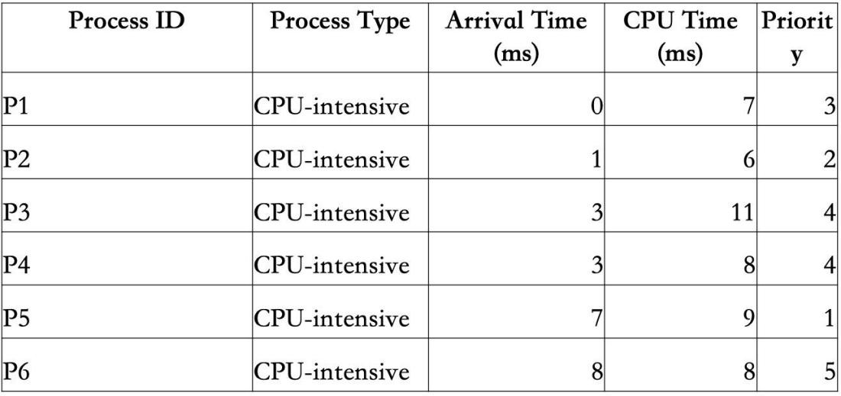

Table 1: Process Group Parameters in CPU-Intensive Scenarios

1. **Round Robin**

The results of the Round Robin scheduling algorithm are as follows：

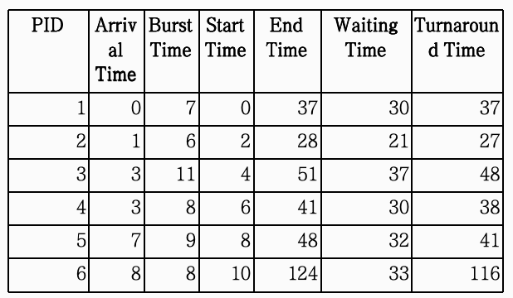

Table 2: Scheduling Simulation

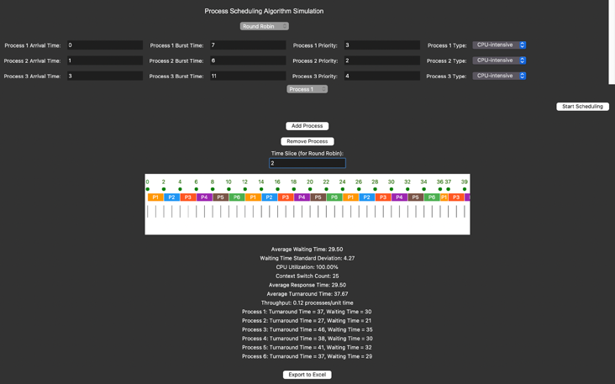

Fig 2: Screenshot of the Application

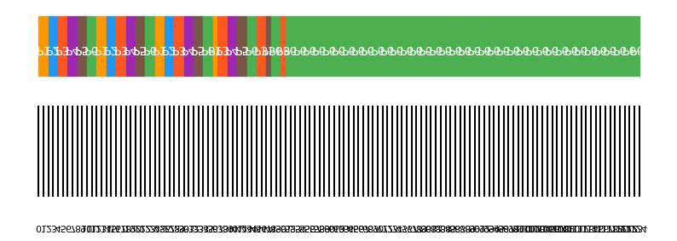

Fig 3: Gantt chart of the Application

Aggregate statistics are as follows：

Average Waiting Time: 29.50

Waiting Time Standard Deviation: 4.27

CPU Utilization: 100.00%

Context Switch Count: 25

Average Response Time: 1.13

Average Turnaround Time: 37.67

Throughput: 0.05 processes/unit time

1. **Shortest Job First**

The results of the Shortest Job First scheduling algorithm are as follows：

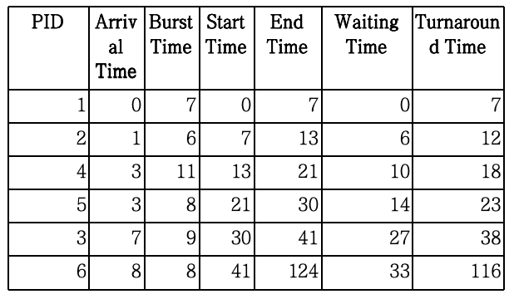

Table 3: Scheduling Simulation

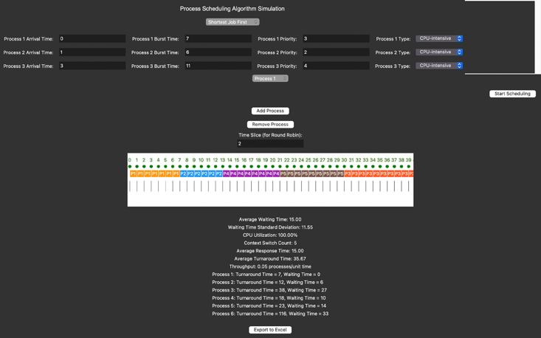

Fig 4: Screenshot of the Application

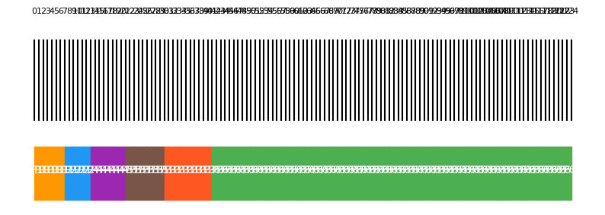

Fig 5: Gantt chart of the Application

Aggregate statistics are as follows：

Average Waiting Time: 15.00

Waiting Time Standard Deviation: 11.55

CPU Utilization: 100.00%

Context Switch Count: 5

Average Response Time: 15.00

Average Turnaround Time: 35.67

Throughput: 0.05 processes/unit time

1. **Priority Scheduling**

The results of the Priority Scheduling algorithm are as follows：

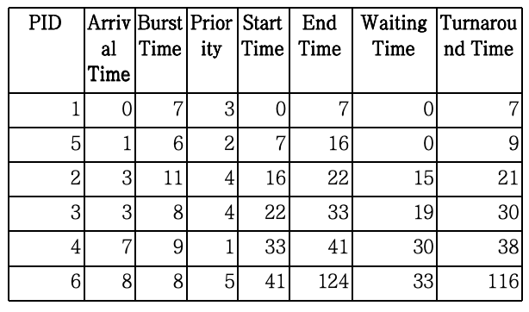

Table 4: Scheduling Simulation

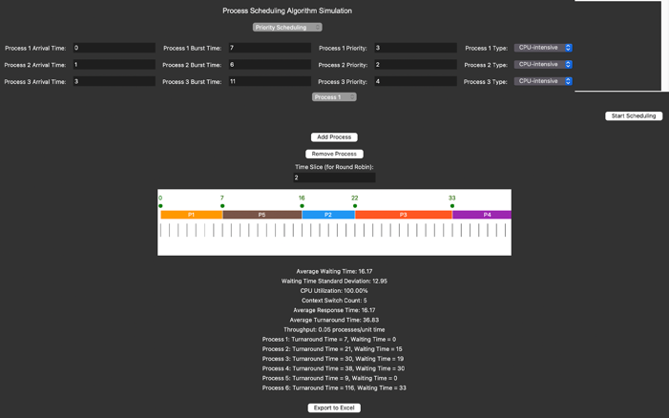

Fig 6: Screenshot of the Application

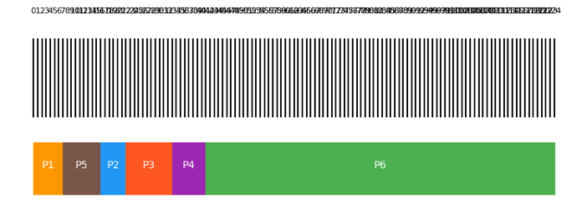

Fig 7: Gantt chart of the Application

Aggregate statistics are as follows：

Average waiting Time: 16.17

Waiting Time Standard Deviation; 12.95

CPU Utilization: 100.00%

Context Switch Count: 5

Average Response Time: 16.17

Average Turnaround Time: 36.83

Throughput: 0.05 processes/unit time

1. **I/O-Intensive Scenarios**

The following is a table of process group parameters for I/O-intensive scenarios:

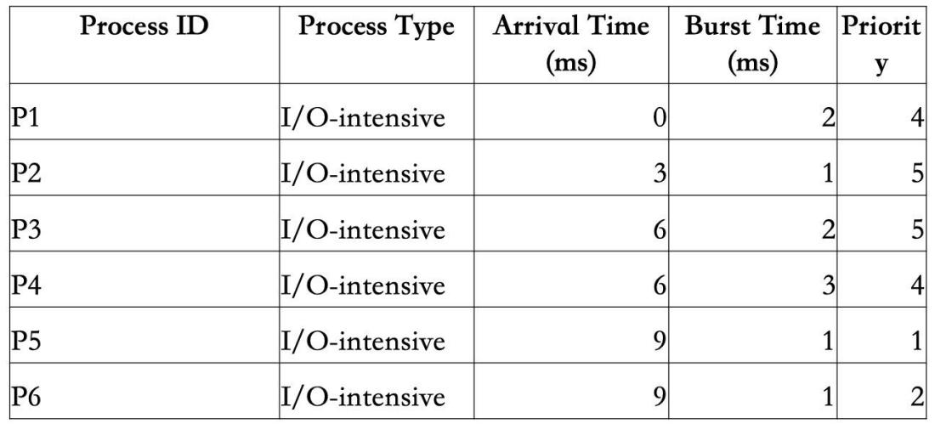

Table 5: Process Group Parameters in I/O-Intensive Scenarios

1. **Round Robin**

The results of the Round Robin scheduling algorithm are as follows：

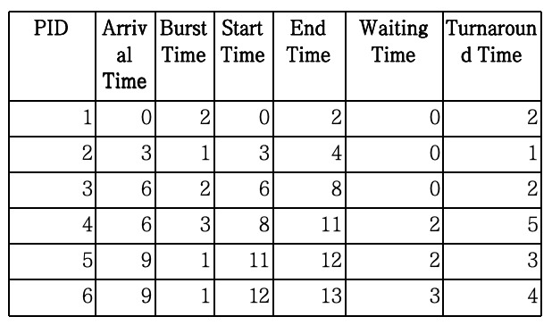

Table 6: Scheduling Simulation

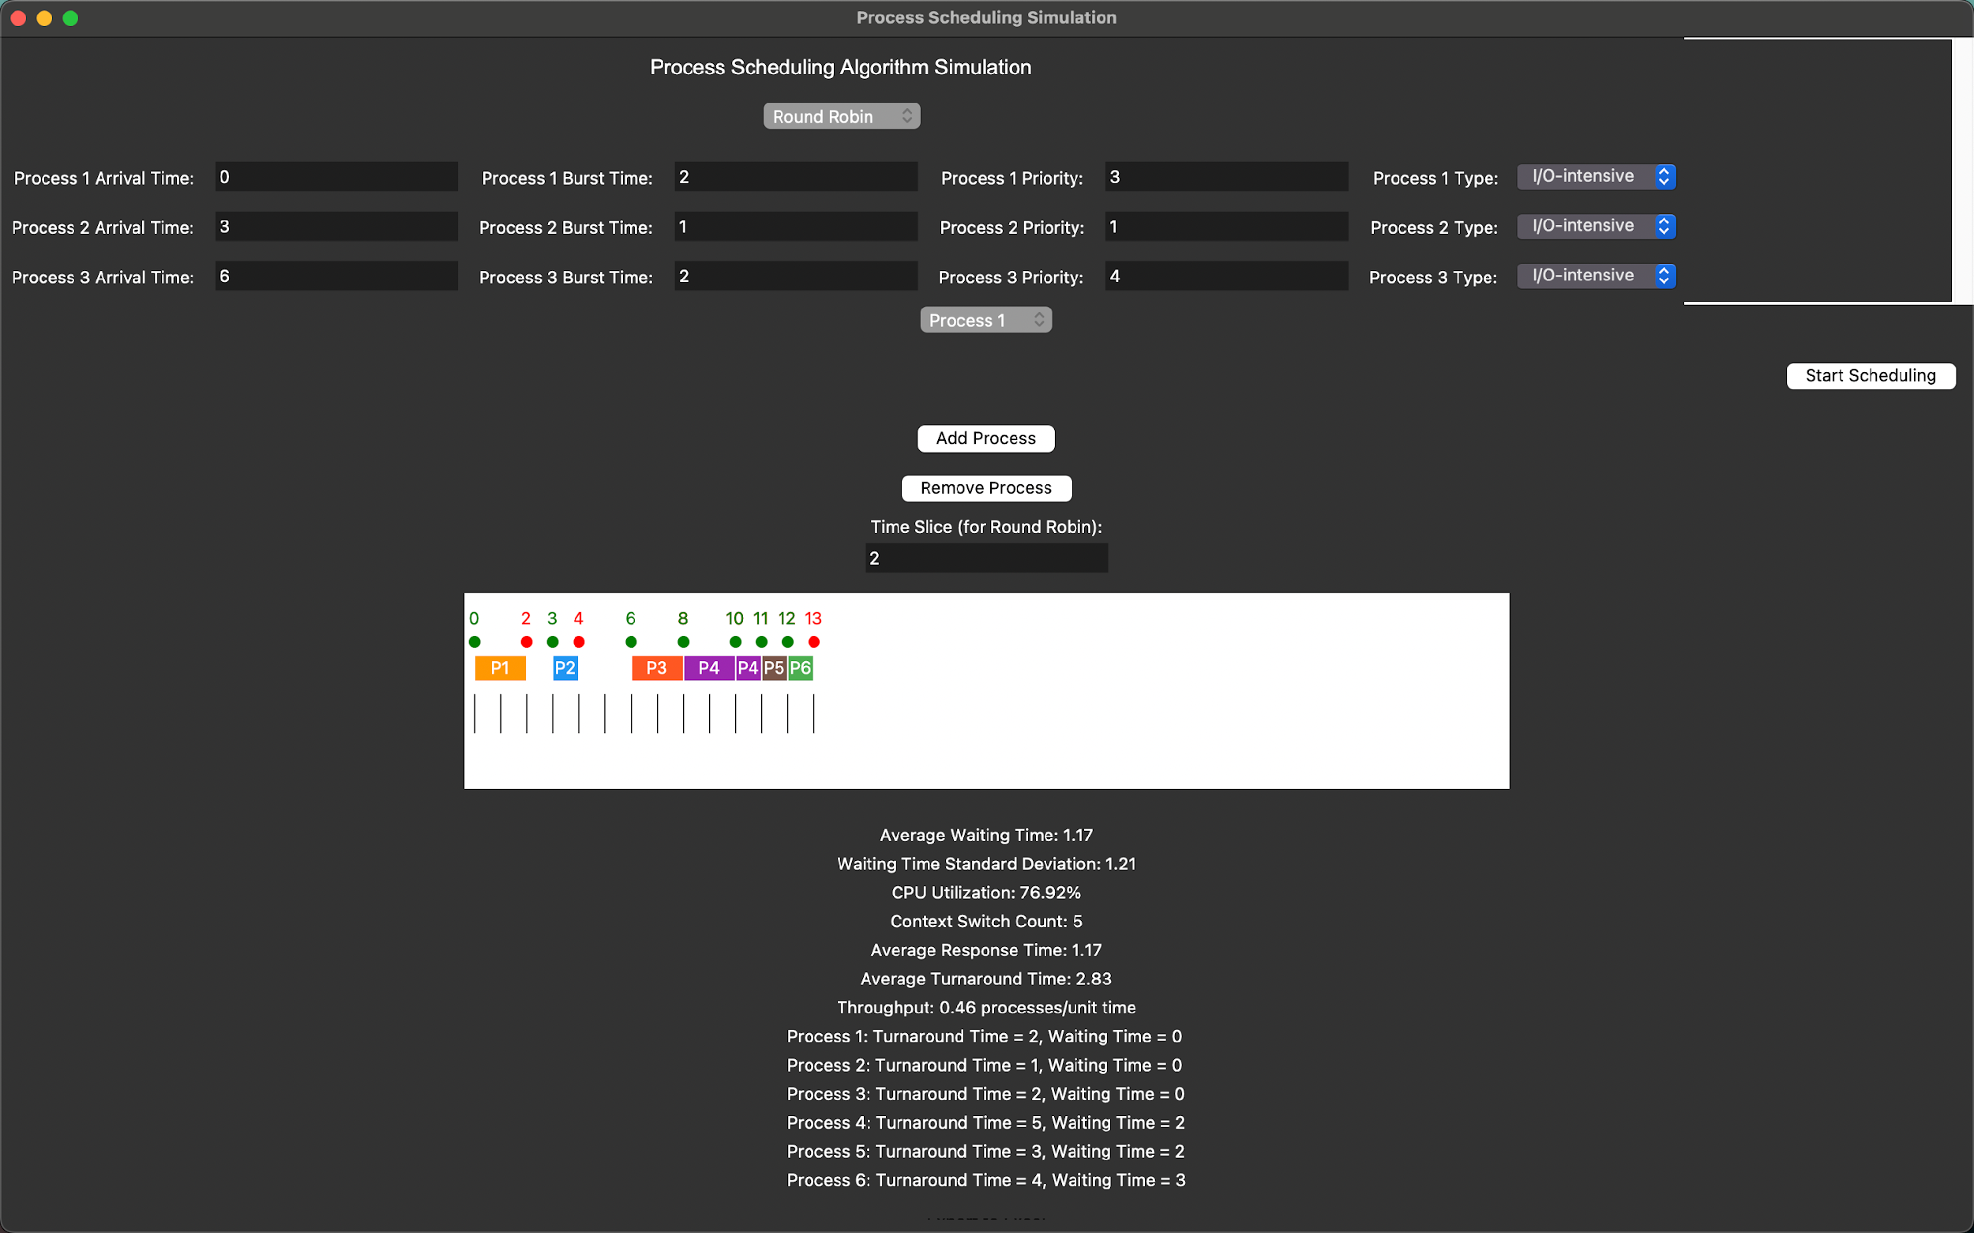

Fig 8: Screenshot of the Application

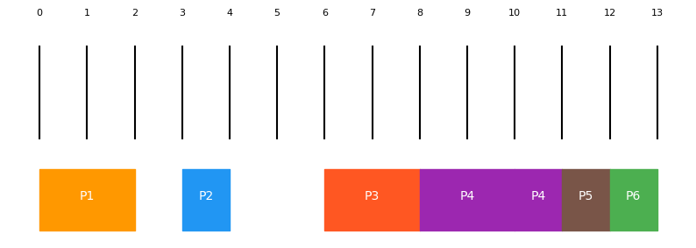

Fig 9: Gantt chart of the Application

Aggregate statistics are as follows：

Average Waiting Time: 1.17

Waiting Time Standard Deviation: 1.21

CPU Utilization: 76.92%

Context Switch Count: 5

Average Response Time: 1.17

Average Turnaround Time: 2.83

Throughput: 0.46 processes/unit time

1. **Shortest Job First**

The results of the Shortest Job First scheduling algorithm are as follows：

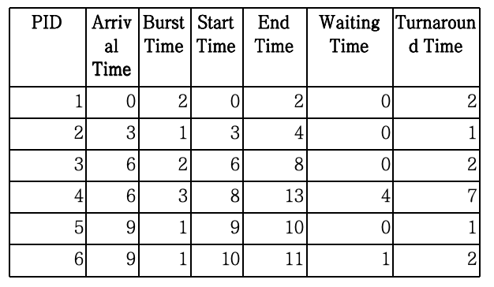

Table 7: Scheduling Simulation

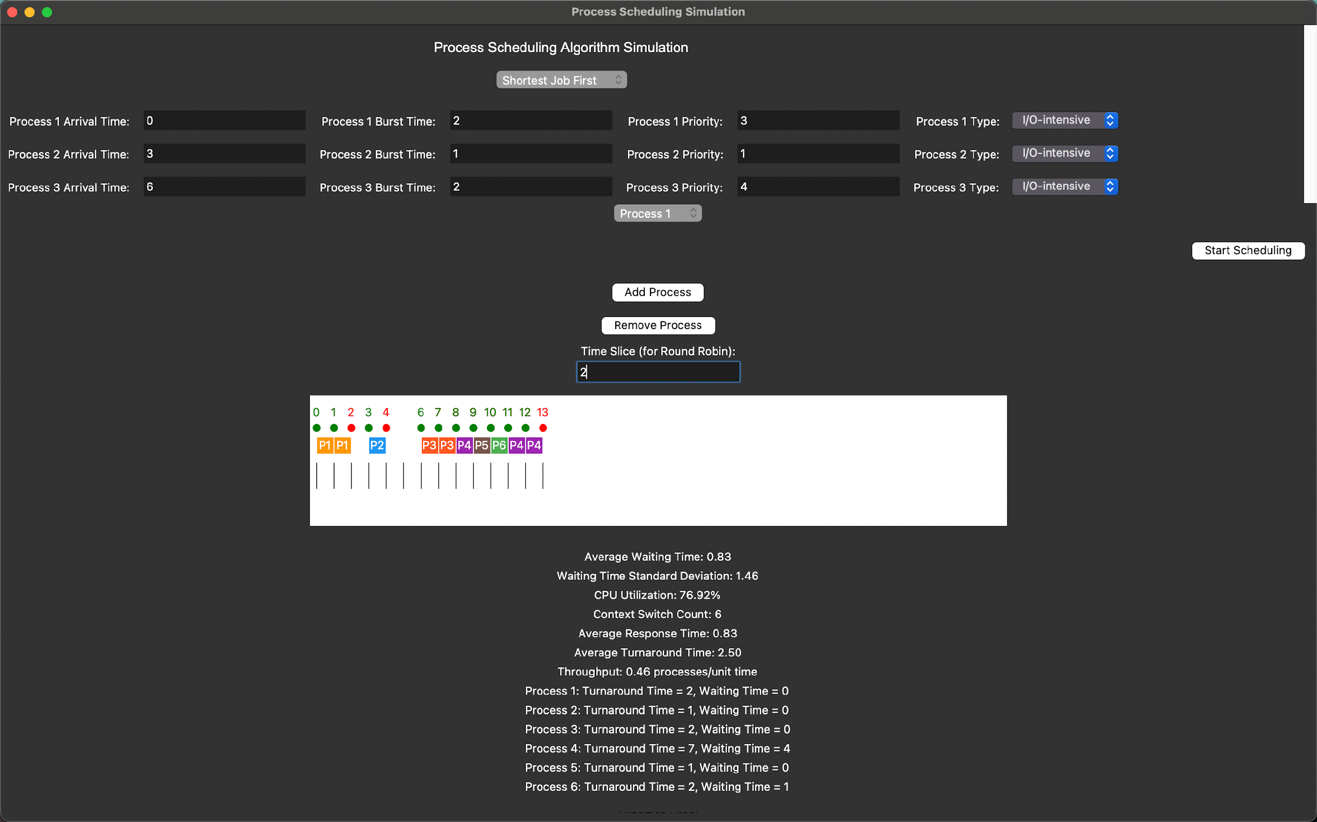

Fig 10: Screenshot of the Application

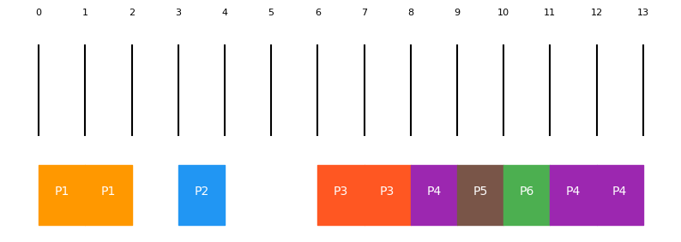

Fig 11: Gantt chart of the Application

Aggregate statistics are as follows：

Average Waiting Time: 0.83

Waiting Time Standard Deviation: 1.46

CPU Utilization: 76.92%

Context Switch Count: 6

Average Response Time: 0.5

Average Turnaround Time: 2.50

Throughput: 0.46 processes/unit time

1. **Priority Scheduling**

The results of the Priority Scheduling algorithm are as follows：

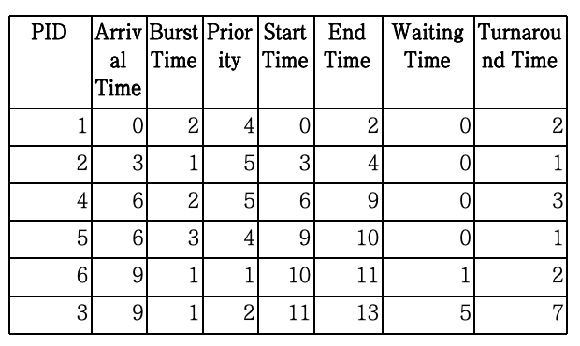

Table 8: Scheduling Simulation

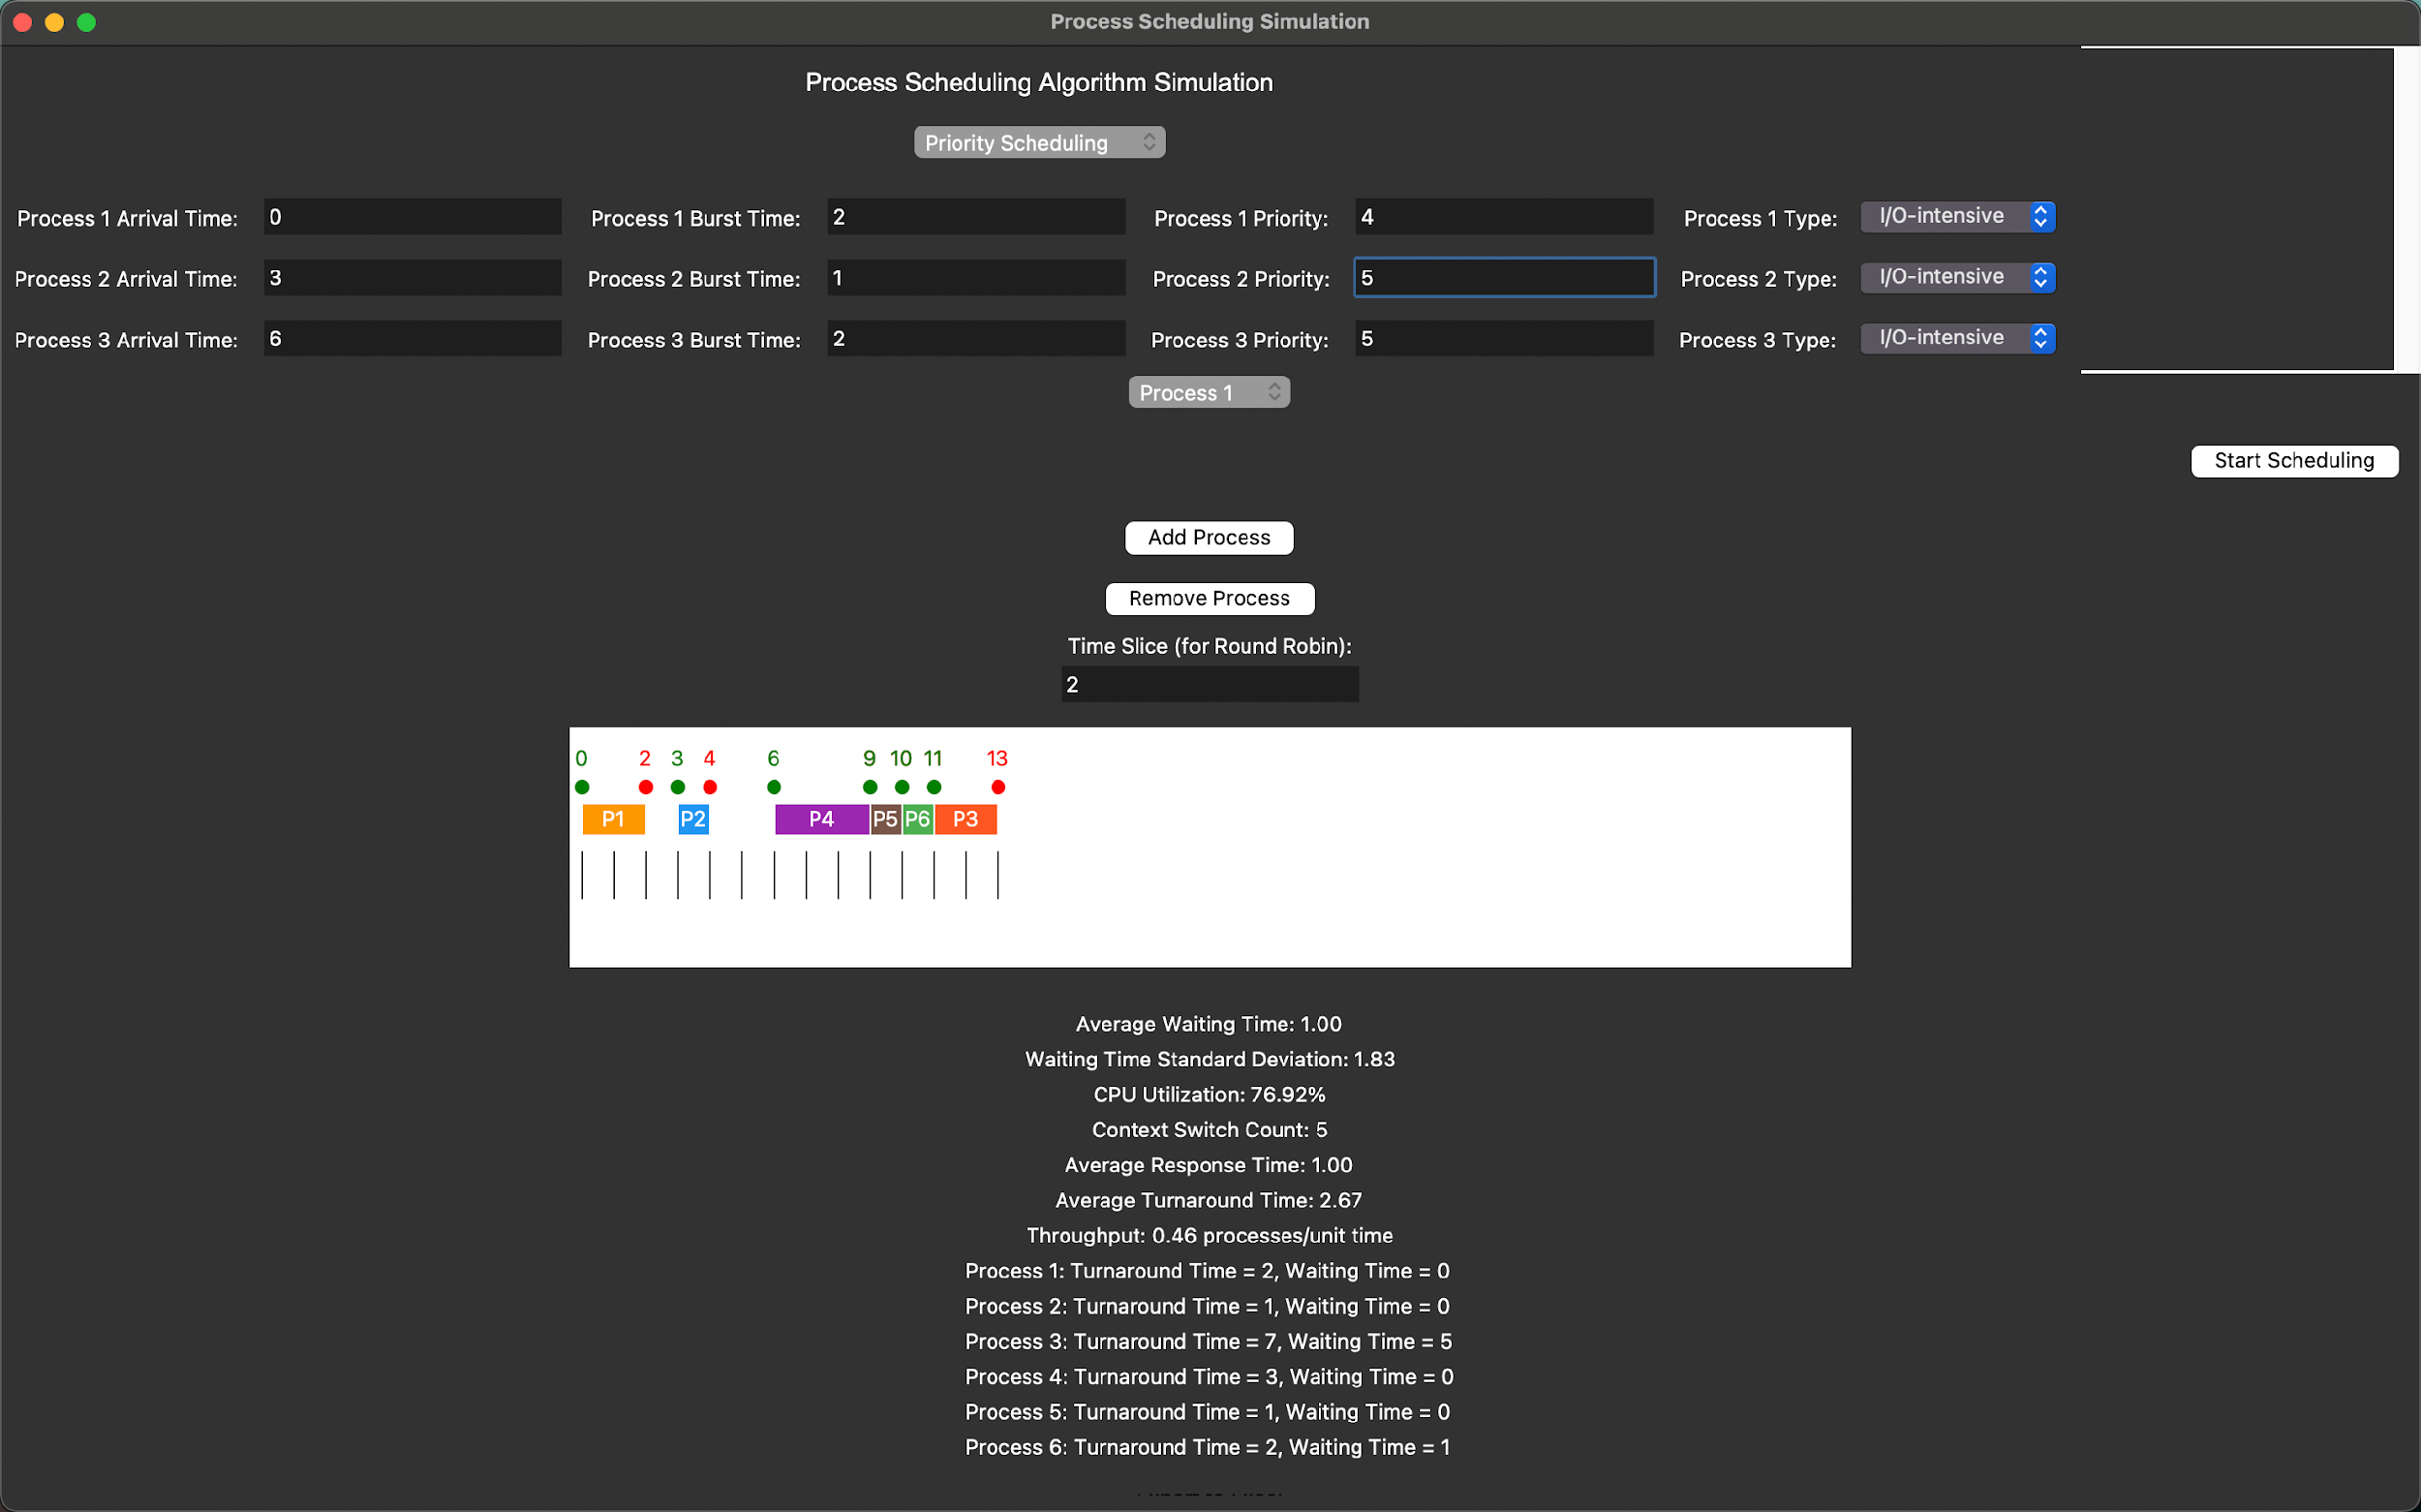

Fig 12: Screenshot of the Application

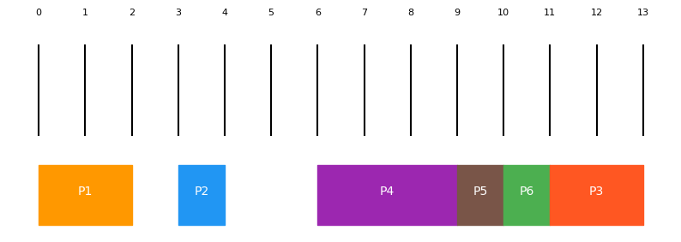

Fig 13: Gantt chart of the Application

Aggregate statistics are as follows：

Average waiting Time: 1.00

Waiting Time Standard Deviation: 1.83

CPU Utilization: 76.92%

Context Switch Count: 5

Average Response Time: 1.00

Average Turnaround Time: 2.67

Throughput: 0.46 processes/unit time

1. **Mixed Processes Scenarios**

The following is a table of process group parameters for mixed processes scenarios:

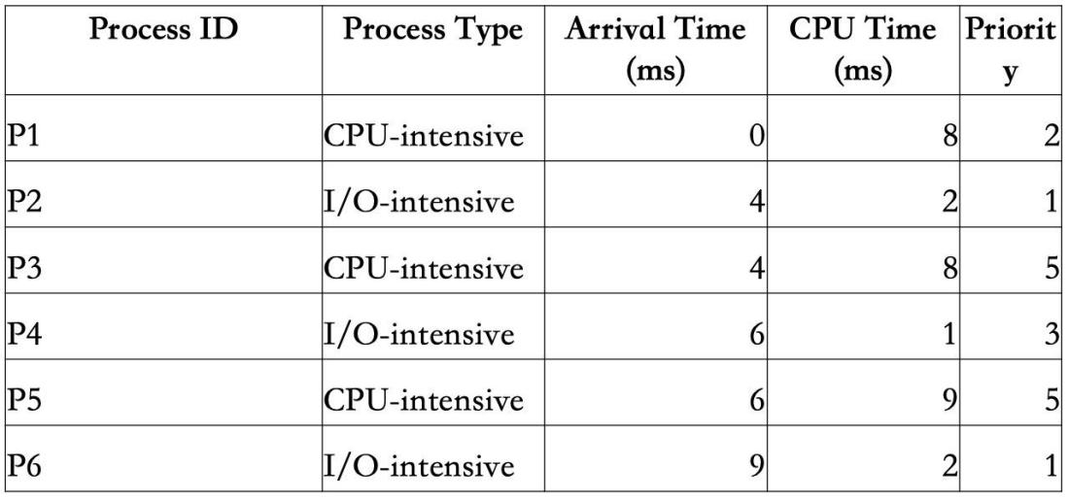

Table 9: Process Group Parameters in Mixed Processes Scenarios

1. **Round Robin**

The results of the Round Robin scheduling algorithm are as follows：

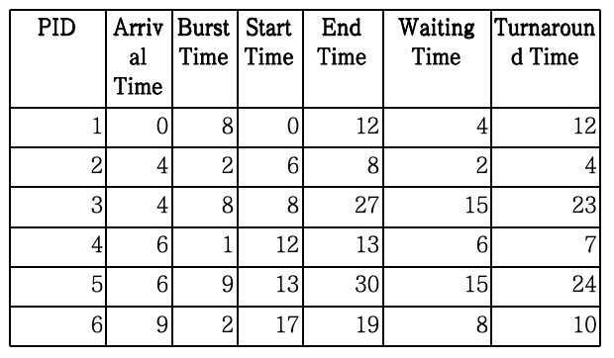

Table 10: Scheduling Simulation

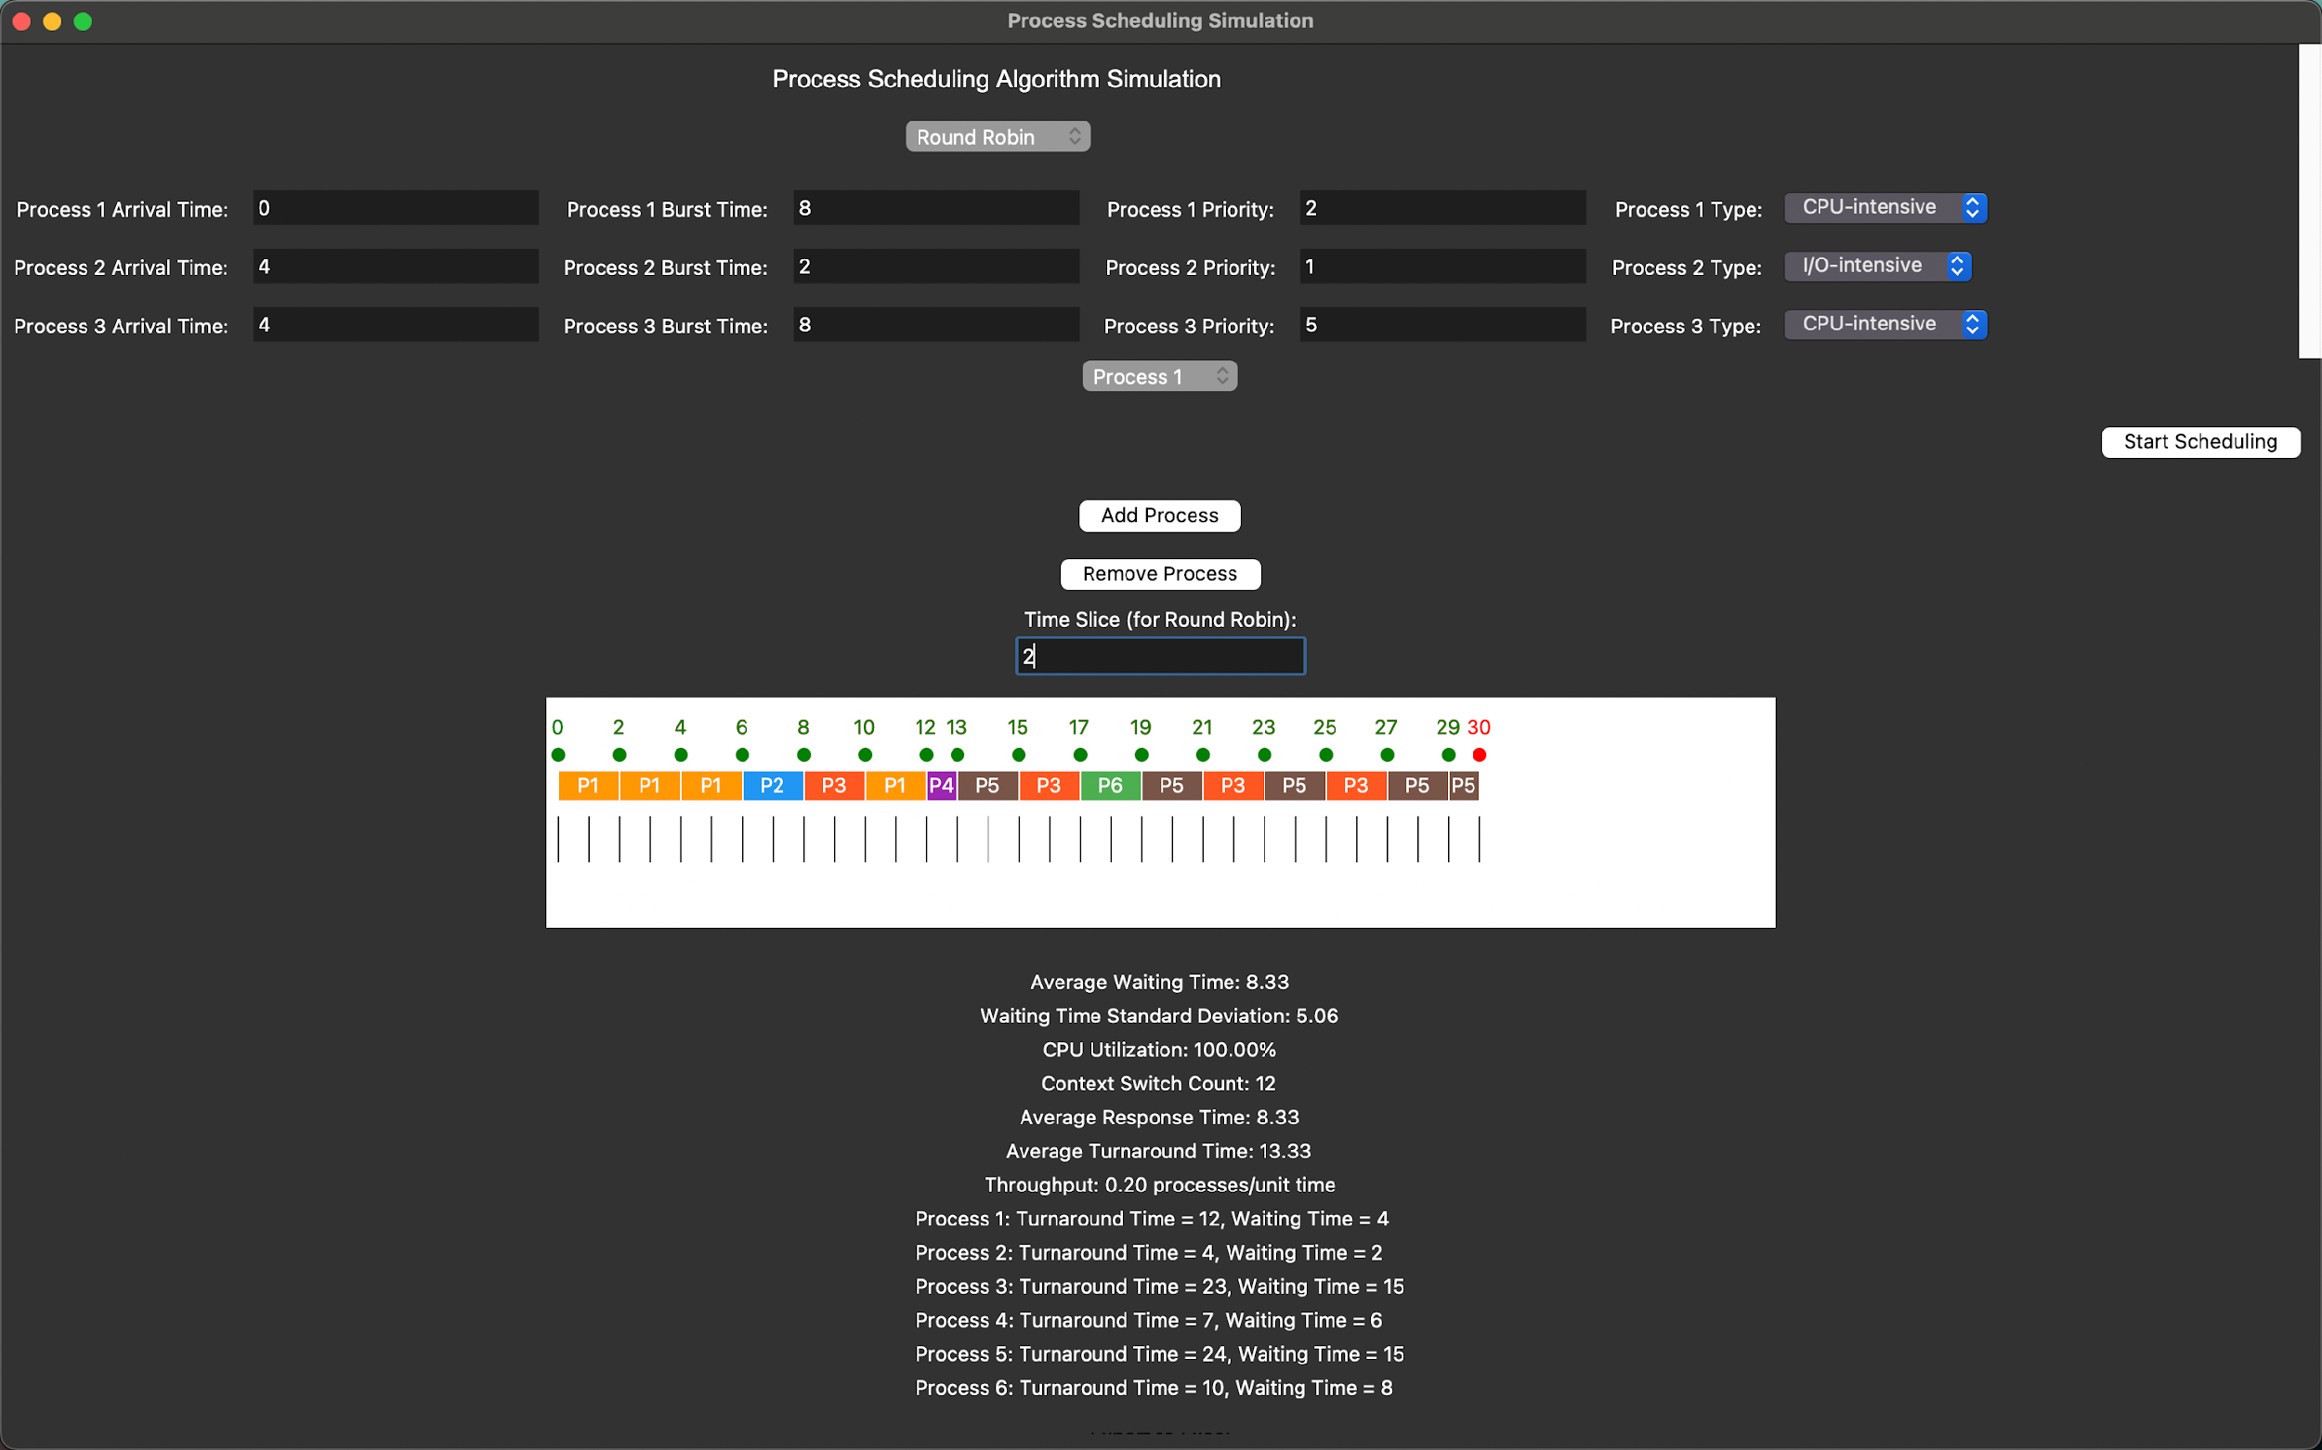

Fig 14: Screenshot of the Application

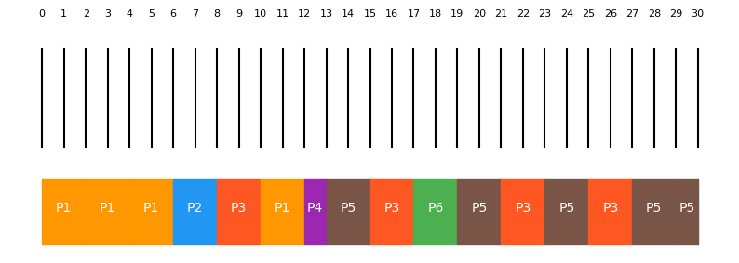

Fig 15: Gantt chart of the Application

Aggregate statistics are as follows：

Average Waiting Time: 8.33

Waiting Time Standard Deviation: 5.06

CPU Utilization: 100.00%

Context Switch Count: 12

Average Response Time: 4.5

Average Turnaround Time: 13.33

Throughput: 0.20 processes/unit time

1. **Shortest Job First**

The results of the Shortest Job First scheduling algorithm are as follows：

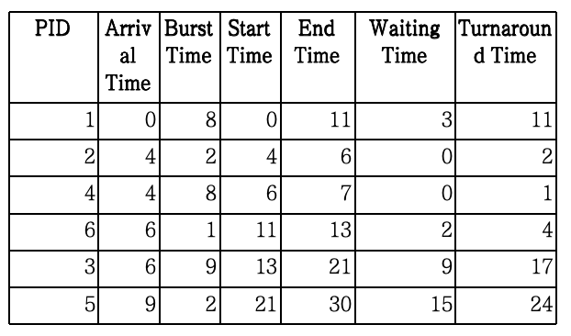

Table 11: Scheduling Simulation

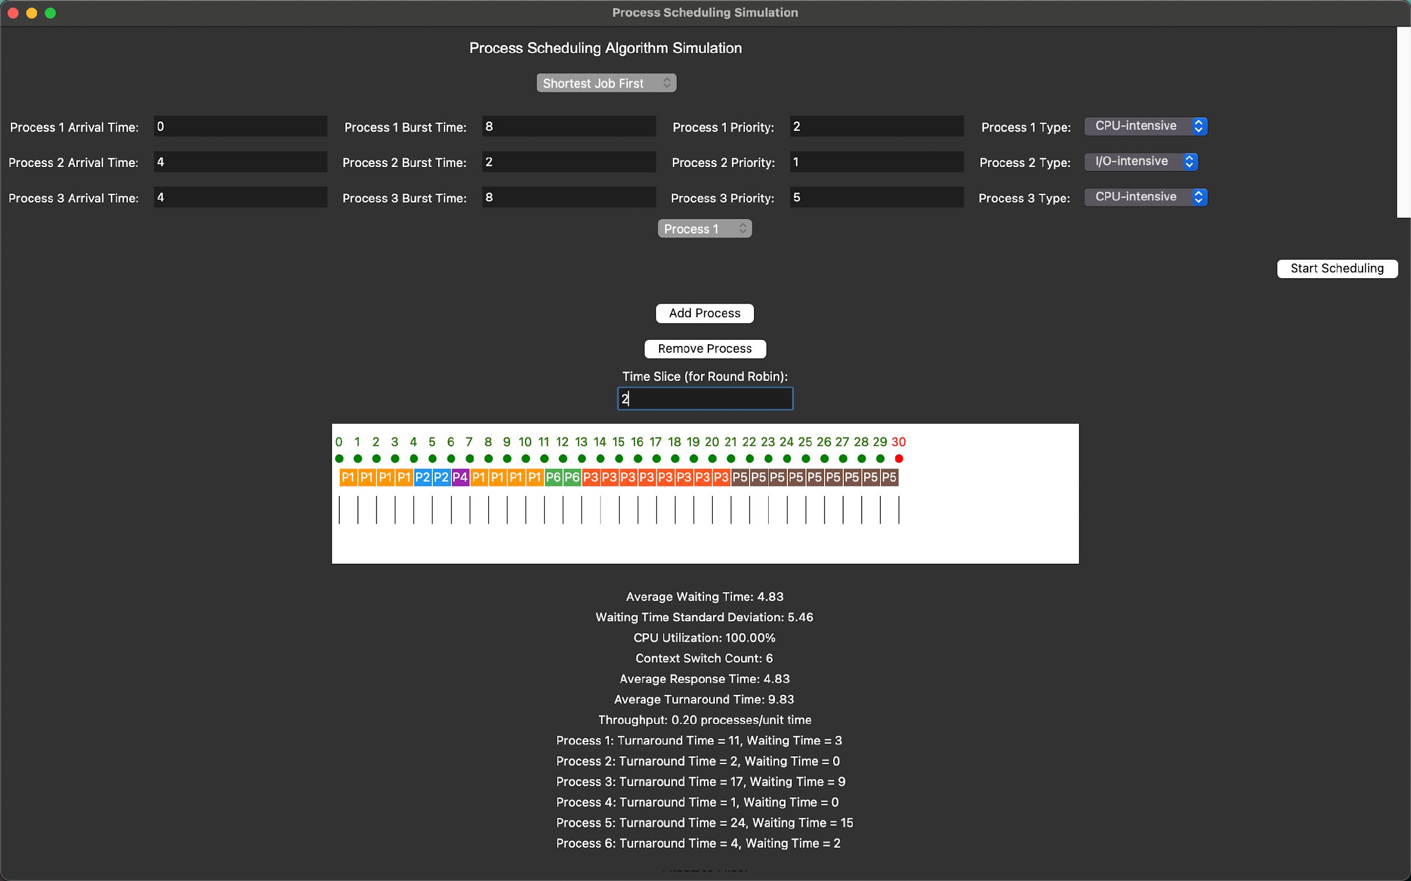

Fig 16: Screenshot of the Application

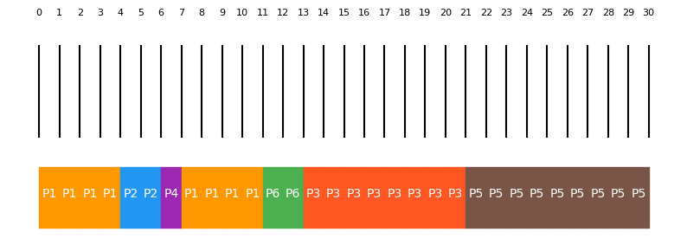

Fig 17: Gantt chart of the Application

Aggregate statistics are as follows：

Average Waiting Time: 4.83

Waiting Time Standard Deviation: 5.46

CPU Utilization: 100.00%

Context Switch Count: 6

Average Response Time: 4.33

Average Turnaround Time: 9.83

Throughput: 0.20 processes/unit time

1. **Priority Scheduling**

The results of the Priority Scheduling algorithm are as follows：

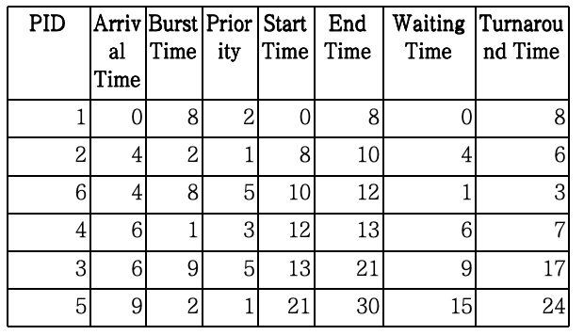

Table 12: Scheduling Simulation

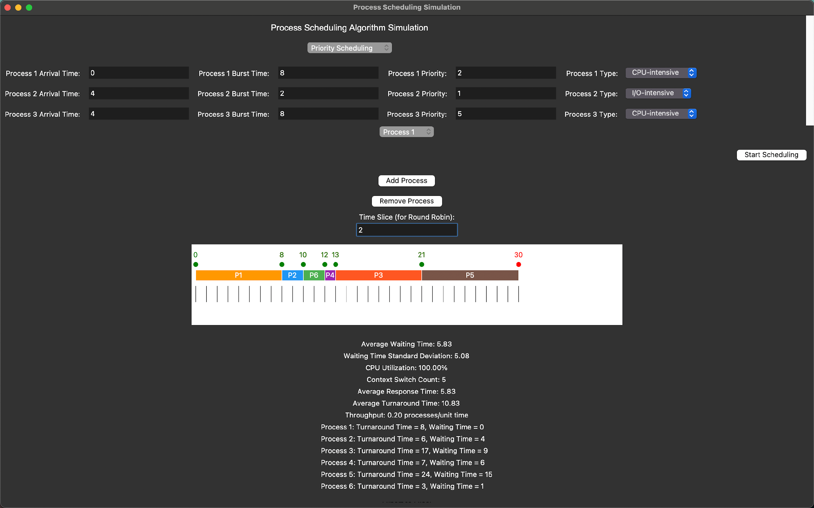

Fig 18: Screenshot of the Application

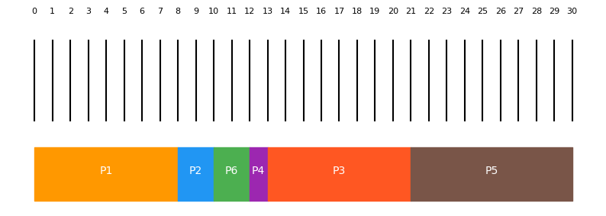

Fig 19: Gantt chart of the Application

Aggregate statistics are as follows：

Average waiting Time: 5.83

Waiting Time Standard Deviation: 5.08

CPU Utilization: 100.00%

Context Switch Count: 5

Average Response Time: 5.83

Average Turnaround Time: 10.83

Throughput: 0.20 processes/unit time

1. **Summary**

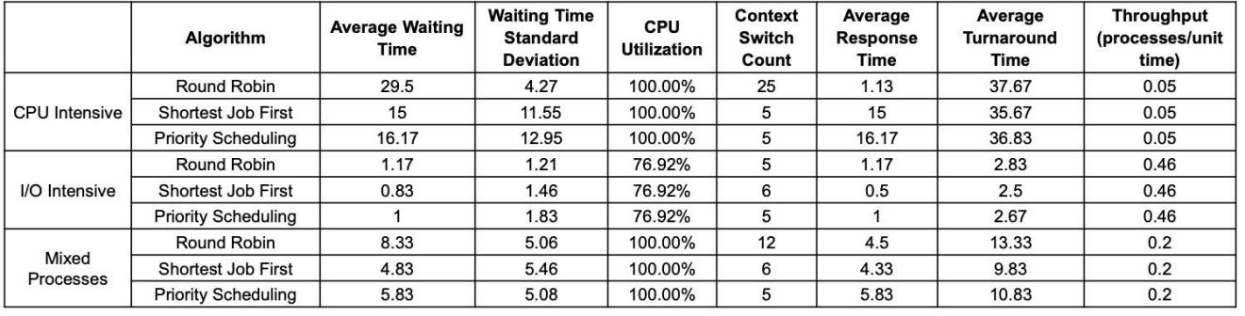

Table 13: Experimental Results Table

**Performance characteristics under different process load types:**

CPU Intensive Scenarios:

* Context Switching: RR switch count (25) significantly higher than other algorithms (5)
* Waiting Time: SJF (15) and Priority (16.17) perform notably better than RR (29.5)
* CPU utilization reaches 100% in all cases, indicating full CPU usage
* Low throughput (0.05), which is typical for CPU-intensive tasks

I/O Intensive Scenarios:

* CPU utilization drops to 76.92%, indicating substantial I/O waiting
* All time metrics show significant reduction (waiting time, response time, turnaround time)
* Throughput increases to 0.46, indicating more frequent process switching
* Performance differences between algorithms are less pronounced

Mixed Process Scenarios:

* Performance metrics fall between the previous two scenarios
* SJF still performs best in waiting time and turnaround time
* RR context switch count (12) remains higher than other algorithms

**Algorithm Characteristics Summary:**

Round Robin:

* Suitable for scenarios requiring high interactivity
* Good response time but high context switching overhead
* Higher waiting times in CPU-intensive tasks

Shortest Job First:

* Best performance in waiting time and turnaround time across all scenarios
* Moderate context switching count
* Most balanced overall performance

Priority Scheduling:

* Performance typically falls between RR and SJF
* Relatively stable performance across different scenarios
* Low context switching overhead

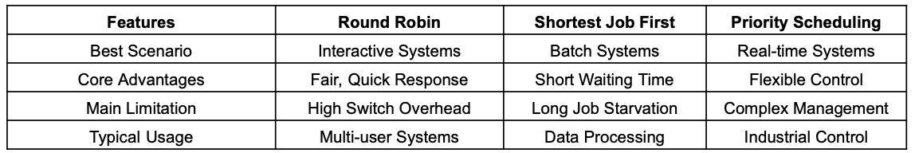

Table 14: The Applicability Table

In CPU-intensive scenarios, the Round Robin (RR) algorithm demonstrates a significantly higher context switch frequency, with 25 switches compared to approximately 5 for other algorithms, indicating substantial overhead for RR in these environments. Shortest Job First (SJF) and Priority scheduling outperform RR in waiting time, with averages of 15 and 16.17 units, respectively, compared to RR's 29.5 units, highlighting their efficiency in reducing waiting time under CPU-bound conditions. All algorithms achieve 100% CPU utilization in these scenarios, though throughput remains low (0.05), which is typical for CPU-intensive tasks where fewer processes are complete per unit of time. In contrast, I/O-intensive scenarios reduce CPU utilization to 76.92%, reflecting idle CPU time due to I/O waiting. Time metrics, including waiting, response, and turnaround times, are notably lower across all algorithms due to reduced CPU load. At the same time, throughput improves to 0.46, indicating a higher rate of process completion as processes frequently yield to I/O operations. In this context, the performance gap between algorithms narrows as I/O-bound tasks reduce the impact of scheduling algorithm choice on performance metrics. For mixed process scenarios, performance metrics are intermediate between those observed in CPU and I/O-intensive environments. SJF continues to excel in waiting and turnaround times, showcasing its versatility and efficiency with diverse workloads. The RR algorithm retains a higher context switch count (12), indicating persistent switching overhead, though it is less pronounced than in purely CPU-intensive scenarios.

**VI. CHALLENGES**

1. **I/O time calculation**

When extending scheduling models to consider I/O operations, the complexity of the scheduling simulator increases substantially.

1. **Context Switching and Interrupt Handling**

Incorporating I/O operations leads to frequent context switching. When a process initiates an I/O operation, the CPU must suspend that process and select another ready process to execute. This switching involves saving the current process's state and loading the state of the new process. Frequent I/O requests result in numerous context switches, which increase the computational load and reduce overall efficiency due to the time spent saving and restoring states.

Moreover, handling these interruptions in a simulator adds significant overhead, as the scheduling logic must now include the frequent movement of processes between different states, including "running," "waiting for I/O," and "ready." The need to frequently check the status of all processes and manage their transitions makes the scheduling process inherently more complex.

1. **Scheduling Decision Complexity**

When I/O is involved, the ready queue's composition changes dynamically, making scheduling decisions more complex. For example, as processes complete I/O operations, they re-enter the ready queue, requiring the scheduler to re-evaluate and update its scheduling decisions frequently.

Schedulers must also consider the interaction between I/O-intensive and CPU-intensive processes to ensure a balanced system. Prioritizing I/O-bound processes to prevent device idle time while also optimizing CPU utilization adds to the complexity. Scheduling algorithms must adapt dynamically, increasing the computational effort to determine optimal scheduling decisions.

1. **Time Management and Event-Driven Simulation**

Managing the timing of events becomes more challenging in simulators that consider I/O operations. These simulators require precise handling of different event types, such as "I/O begins," "I/O ends," and "process starts running." A vital aspect of this management is an event-driven mechanism that accurately simulates the timing of these events.

The event-driven model must account for each I/O operation, including when it starts and ends, CPU time slices, and process arrivals. Maintaining an accurate timeline for all these events and ensuring that each event is handled in the correct sequence requires sophisticated event scheduling and time management mechanisms, which significantly increase the simulator's computational complexity.

Incorporating I/O operations in process scheduling significantly increases the complexity of scheduling simulators. Managing context switches, dynamic scheduling decisions, time management, and unpredictability makes the simulator more challenging to implement and computationally expensive. When designing process scheduling systems that more accurately reflect real-world conditions, these factors must be considered, particularly in environments where CPU and I/O operations coexist and interact dynamically.

1. **Too many process inputs**

Too many process inputs may significantly increase the tool's computational effort, causing performance issues and limitations that may lead to inaccurate calculation results. The reasons for this and possible specific impacts are detailed below.

1. **Impact of increased calculation amount on performance**

In a multi-process scheduling simulation tool, the input data of each process (such as arrival time, running time, priority, etc.) will impact the execution time of the scheduling algorithm and the overall performance of the tool. When the number of input processes is too high, the tool may face the following performance issues:

Increased processing time: Scheduling algorithms, such as Round Robin, Shortest Job First (SJF), and Priority Scheduling, calculate the scheduling order, waiting time, Context switching, etc. When too many processes are fed in, the complexity of these calculations increases exponentially, causing the tool's responsiveness to drop significantly.

For algorithms with higher time complexity, such as Preemptive Short Job First (Preemptive SJF) or priority-based scheduling, the system needs to continuously re-evaluate each available process to find the current process that should be executed, which is very important for the processor. The resource requirements are very high, especially when there are hundreds of processes, and this amount of computation can cause the tool to slow down significantly.

Increase in memory usage: For each process, the system must store multiple parameters such as arrival time, running time, priority, etc. In addition, tools may need to save the state of each process at each step in the scheduling process. This data will occupy memory. When the number of processes is too large, the increase in memory consumption can also lead to a decrease in system performance, especially when hardware resources are limited.

Frequent occurrence of context switches: When using algorithms like round-robin scheduling, the system must perform context switches frequently when the number of processes increases. Context switching requires saving and restoring the state of the process, which increases system overhead and leads to poor overall performance.

1. **May lead to inaccurate calculation results**

When the number of input processes reaches a particular scale, it may cause inaccurate calculation results. This is mainly due to the following reasons:

**Floating point precision issues:** Due to the precision limitations of floating point numbers, cumulative errors may occur during many calculations. For example, calculations such as waiting time and turnaround time involve many addition and subtraction operations, and the accumulated floating point error will be reflected in the final result. This error is more evident in the case of many processes, thus affecting the accuracy of the calculation results.

**Algorithm limitations:** The priority effects of many scheduling algorithms may be affected when facing many processes. For example, in priority scheduling, lower-priority processes may be delayed for extended periods (called starvation problems), causing wait times to become abnormally long. If appropriate aging mechanisms are not implemented, these processes may never be scheduled, affecting scheduling fairness.

**Resource competition and deadlock:** When many processes exist simultaneously, the scheduling system must manage multiple methods' resource requirements. Although resource management may not be implemented directly in this simulation tool, in a natural environment, resource contention, and deadlock will typically prevent some processes from completing their execution. Resource management's complexity may affect the scheduling algorithm's correctness and cause the simulation results to deviate from the actual situation.

**GUI response and lag:** In GUI tools (such as Tkinter), input processing from many processes may cause interface lag. Tkinter is single-threaded, and the blocked GUI thread means the user cannot interact with the tool, such as entering more data, clicking buttons, etc. Long lag periods will result in an inferior user experience, and the user may think the tool has crashed.

**VII. FUTURE STUDY**

Future research could focus on optimizing these simulation models to handle I/O operations more efficiently. This might involve exploring alternative approaches to managing asynchronous events, reducing context switch overhead, and developing algorithms that better balance the competing demands of I/O-bound and CPU-bound processes.

To solve the performance and accuracy problems that too many process inputs may cause, some optimization measures can be taken:

**Limit the number of processes input by the user:** Developers can set input limits through the GUI interface, allowing users to input no more than a certain number of processes (such as 50), to reduce the computing pressure and ensure the system's stability and accuracy.

**Use multi-threading or multi-process processing:** Developers can separate the computing part from the GUI part and put the computing into the background thread so that the GUI part can remain responsive even if the computing time is extended. Python's threading module or multiprocessing module can help achieve this.

**Use more efficient data structures and algorithms:** Developers can optimize the scheduling algorithm to reduce its time complexity as much as possible. For example, in round-robin scheduling, if the time slice is too small, resulting in frequent context switching, you can appropriately increase the time slice to reduce the overhead of context switching.

**Cache and segmented calculation:** For large amounts of calculation, developers can first use cache or segmented processing methods to calculate and store some results to reduce the overhead of repeated calculations.

**Improve visualization:** When the number of processes is large, each process block on the timeline may be tiny and difficult to distinguish. The timeline presentation can be improved by using a zoom function or segmented display so that users can better understand the scheduling process.

**VIII. CONCLUSION**

The scheduling simulator provides a visual and interactive approach to understanding CPU scheduling algorithms. By incorporating fairness, efficiency, and resource utilization metrics, the tool facilitates a comparative analysis of scheduling algorithms, enabling users to evaluate performance under various scenarios.

Round Robin is particularly suitable for systems that require high interactivity, as it offers superior response times. This makes it ideal for environments where responsiveness to user inputs or rapid task switching is essential despite its higher context-switching overhead.

Shortest Job First (SJF) is recommended for scenarios where efficiency in overall performance metrics, such as waiting and turnaround times, is critical. Its ability to minimize waiting times makes it practical for systems focused on throughput and prompt task completion while maintaining moderate context switching.

Priority Scheduling is well-suited for systems where task prioritization is essential. It provides a stable and balanced performance across different types of workloads, with a relatively low context-switching overhead, which is beneficial for tasks with varying levels of urgency.

SJF is often the optimal choice in mixed workload environments, as it provides well-rounded performance that effectively addresses CPU and I/O requirements. Its balanced handling of workload types makes it versatile for systems with diverse tasks.

These insights offer a comprehensive perspective on the strengths and weaknesses of each scheduling algorithm, helping you select an appropriate CPU scheduling strategy tailored to specific system requirements. By understanding the characteristics of each algorithm, decision-makers can optimize system performance based on the particular workload demands.

Future improvements include adding more scheduling algorithms, such as Multilevel Queue and Multilevel Feedback Queue, and expanding resource utilization analysis to account for I/O operations.

**REFERENCE**

1. A. A. Alsulami, Q. A. Al-Haija, M. I. Thanoon, and Q. Mao, "Performance Evaluation of Dynamic Round Robin Algorithms for CPU Scheduling," *2019 SoutheastCon*, Huntsville, AL, USA, 2019, pp. 1-5, doi: 10.1109/SoutheastCon42311.2019.9020439.
2. L. Kishor and D. Goyal, "Comparative Analysis of Various Scheduling Algorithms," *International Journal of Advanced Research in Computer Engineering & Technology (IJARCET)*, vol. 2, no. 4, pp. 1488, 2013.
3. O. Hajjar, E. Mekhallalati, N. Annwty, F. Alghayadh, I. Keshta, and M. Algabri, "Performance Assessment of CPU Scheduling Algorithms: A Scenario-Based Approach with FCFS, RR, and SJF," *Journal of Computer Science*, vol. 20, no. 9, pp. 972-985, 2024, doi: 10.3844/jcssp.2024.972.985.